quick Start guide
This quick start guide is designed to get you up and delivering samples in under an hour. For more comprehensive help topics, please visit https://trucentivemail.com/Help

Sign up
Signing up with Trucentive starts at https://www.TruCentive.com
In the upper right-hand corner of the home page, you will find the signup button.
- Enter your account information. The sign-up email address will the primary email associated with the account, but it can be changed, and additional users may be invited to your account.
- Once you sign up you will see a conformation screen with a notification for the delivery of your verification email.

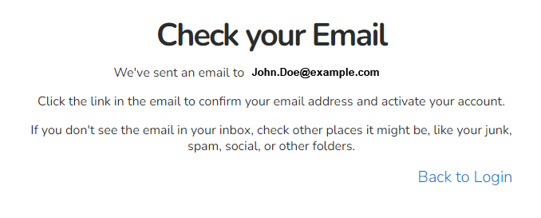

- Confirm your account from your sign-up email
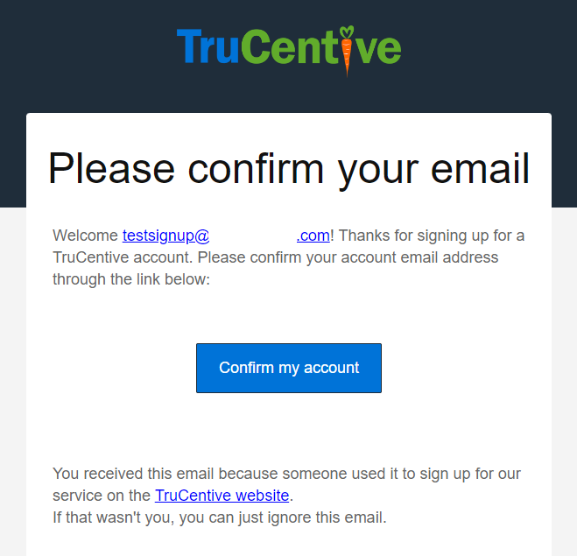
- You will then be directed to the login screen, and you can begin designing your first project!
Note: It takes approximately 4 business hours to verify your account. During this time you can:
- Create and send test samples to only to yourself
- You will not be able load funds for incentive deliveries
- If you plan on sending more than $1500 per month you will want to fill out your KYC (know your customer form). The KYC is a legal document that is required due to the 2001 Patriot Act, this document protects you as the user and us as the merchant against fraud and money laundering. It is just one more way that we keep your business extra safe while using our platform! Click here to start your KYC form: https://trucentive.com/know-your-customer/

Account Menu
When you log in to your account you will see a handy tool bar on the left side of the screen. This is where you can access everything in your account.
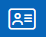
Start by clicking on the account icon. Click on Account Overview and finish filling in all your company information. This will come in handy as you need this completed before you can send any type of incentive, even in test mode
Select Members, to invite other members in your company that you want to give access to. You can invite them to your account or to specific projects. You can also choose their role to limit capabilities. Hint: you can delegate what kind of role that you would like them to hold. Click here to see role definitions: https://trucentivemail.com/Help/knowledge-base/what-are-the-user-role-definitions/

Role Definitions
Administrator - The most powerful role in a Project or Account. At the account level, can manage users that are invited to the account or any project in the account; can examine all Project activity and view message deliveries for any particular project. Can create/edit/delete any Project in the account. Can perform all operations on envelopes. Can access any level of reporting. A Project Administrator can invite others to a project (but not to any other project or an account). A Project Administrator can view reports, message deliveries, etc., related to the project.
Auditor - Can view the details of all Projects as an Account Auditor. As a Project Auditor can view individual projects. Envelope deliveries can be viewed. Envelope information can be viewed. Activity logs for a project can be viewed. Account auditors can view the list of account members, account funding details, account details, and project details. They generally cannot change anything.
Funder - Can perform auditing functions in an account AND change project funding detail.
Creator - In general, can create projects, change the design/parameters of a project, create test envelopes, and examine those test envelopes. They cannot originate non-test envelopes.
Requestor - In general, can generate an envelope using an existing Project in the test or non-test mode from a single contact or uploaded list of contacts. Some characteristics of the envelope may be changed if the project allows it. The envelope is not immediately sent; however, it is referred to another user (Administrator, Approver) for review and approval, at which time it is sent. They can view the delivery details of envelopes that they requested and that were approved.
Approver - In general, can create an envelope from a Project, can change a Project's default amount, and the instrument can change an envelope's outgoing message. Can examine a requested envelope's contents and then approve or revoke it. As an Account Approver, they can see who a member of the account is and view funding information.
API Access – Allows you to create API Access Grants that can be used to enable programmatic access to certain projects with particular roles from other applications.
Notifications – This is where any account notifications regarding your account will show up. This will include items such as envelopes that a requester has requested but still need approval.
Custom Fields – this is where you can add new custom fields for contacts, i.e., birthday or company anniversary.
Funding Reminders – here, you can set up specific funding reminders to notify multiple email addresses (finance, etc.) when you have reached a specified low balance for a particular account or project

Billing – the billing menu will only appear after your account has been verified. Once verified you may add your funding source and add funds. First you will want to go to the payment tab where you can add your either your credit card or bank account information. See the specifics about time and fees associated with certain payment types here: https://trucentivemail.com/Help/knowledge-base/what-are-my-payment-options/
Note: You may also request an invoice which will be sent via email. The invoice will include instructions to pay via ACH, Wire Transfer, or Credit card https://trucentive.com/request-an-invoice/
The Usage tab has information on all invoices and funds may be added to your account by clicking the blue add funds button at the top right of the screen.
Note: For detailed instructions on how to add funds, click here: https://trucentivemail.com/Help/knowledge-base/how-do-i-add-funds-to-my-account-2/

Projects
TruCentive is a project-based Incentive fulfillment and rewards delivery platform. You can create projects for a wide variety of use cases from employee incentives to a customer thank-you.
Note: When you create a project it is ALWAYS in test mode. You can send samples to yourself and colleagues using “test funds.” This allows you to build and test projects without worrying about sending rewards and incentives with real monetary value.
Now on to the fun part!

Building a new project
On the home screen, click on the blue “Add New Project” button in the upper right-hand corner of the screen. This will take you to the template page. From here, you can choose one of our pre-built templates. Whether you pick a simple default template or one for an occasion, all aspects of your template and project can be modified at any time so if you see a template that you like the style but want to use for a different application, don’t hesitate!
Once you select a template, a pop-up window will ask you for a project name and optional project description. You can always go back and change this at any time.

Project Tabs

Overview
The overview tab gives you a top-level view of your project, including delivery details, available funds, and a chart showing delivery statuses.
Note: In test mode, you will see test deliveries; in live mode, you see actual deliveries with monetary value.

Settings
- Edit the project name and description
- Link to Project Members with the option to invite additional members
- Test Mode - (Default = On) (Off=Live and uses real funds vs. test funds)
- Project Dates - this setting is optional and sets a start and end date to a project that restricts the time period that a contact can be added to the project. We recommend leaving this blank for ongoing projects.
- Envelope Expiration – this sets the incentive expiration date or number of days from delivery for an incentive to expire. i.e. the amount of time that a recipient will have to claim their gift card. After that envelope expiration, the incentive value of an unclaimed incentive is returned to your account.
Note: this period does not affect how long the recipient has to USE a claimed incentive.
Gated Deliveries – this is a feature that would allow you to create specific codes for access to gift cards; useful if you are wanting the recipient to perform a specific action before they are allowed access to their gift i.e., you are at a trade show and give people who visit your booth a $5 coffee gift card
From Addresses - this shows the email and text number from which your incentives will come. If you want to personalize this, you can manage it by clicking on the blue words “account settings”
Note: If you would like to send from your own email and domain, please contact support for setup instructions. While it is a simple process, it will require assistance from your IT department. This is a best practice and is highly recommended to receive maximum recognition for your incentives.

Incentive
This is where you will set your incentive amount or range and choose your gift cards, merchandise, and/or payment options for delivery to recipients.
At the top of the tab, you will see the value settings for your project.
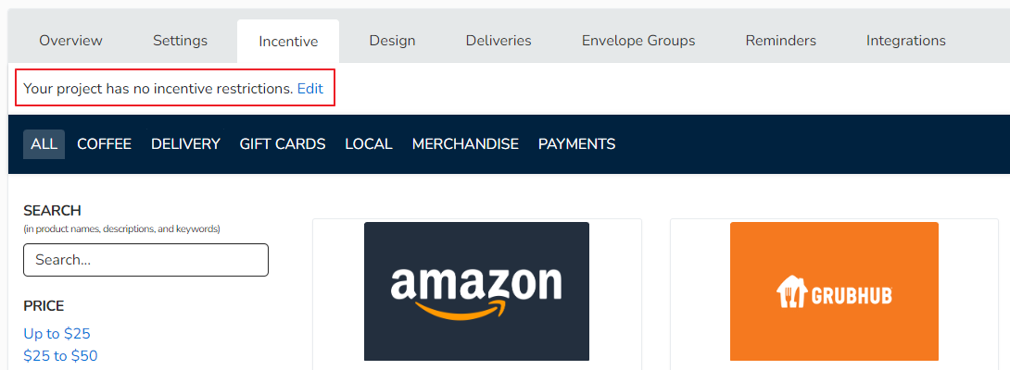

Incentive Settings
The incentive settings popup lets you set the value for the incentives you intend to send.
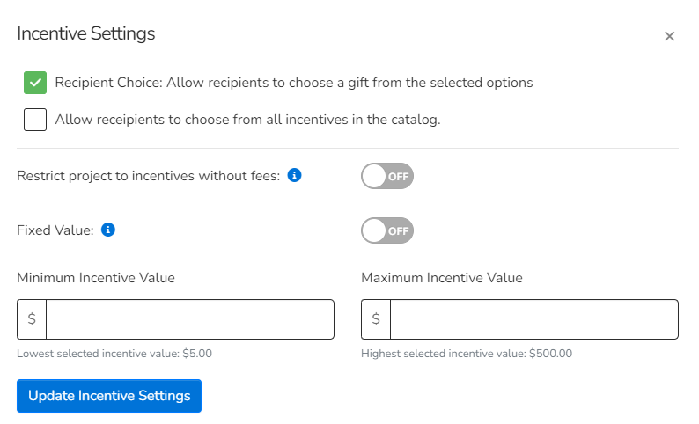
Recipients Choice – Let’s you turn on or off the option for your recipients to choose from your curated selection of incentives.
ON – Allows recipients to choose from your selection of incentives upon receipt.
OFF – Allows the sender to choose from your selection during the send process.
All Catalog – Allows the recipients to choose from everything in the TruCentive Catalog. This includes all gift cards, local gift cards (by zip code and type), merchandise, and payment options. The recipient’s selection will be limited to the value of the project (they will only see options that meet the criteria) and the availability of their country of choice.
Restrict Incentive Fees – Some incentives have a premium charge from the merchant. PayPal, Venmo, Deposit to Debit card, Visa, and MasterCard cards. Have an additional charge (noted on the selection tab) If you would like to offer “all catalog” but do not want to include items that charge a premium, set Restrict Incentives = ON, and the recipient will only have access to non-premium incentives. Note: The max premium on any item in the TruCentive catalog is $2.00 or 2%. We do not accept cards with higher premiums.
Fixed Value – You can set your project to a fixed value. With fixed value = ON, all incentives will be set to that value except for merchandise. Only selected merchandise below that value will be displayed to recipients.
Note: Any recipient-selected merchandise items that are below the value or max value set by the sender will have the difference returned to the sender’s account. Prices on the merchandise are not displayed to the recipient.
Min and Max Value – If you turn on the min and max value and enter no value at the time of sending, the sender will be requested to add a value between the range. This selection may also be turned on if you are integrated with another system and want to set min and max values on what is being delivered via the integration and sent. Set a min and max value and any value delivered below the min value will be rounded up to the min value, and any value over the max value will be rounded down to the max value. This gives trucentive Admins and Approvers control over external systems sending incentives.

Group Bar
The group bar lets users select different pre-selected groups to assist in the selection of incentives.
Options include ALL (full card catalog), COFFEE (coffee-specific cards), DELIVERY (delivery service cards), GIFT CARDS (merchant cards), LOCAL (local merchant cards), MERCHANDISE (physical gift items), PAYMENTS (cash option cards) these options are periodically updated to improve the selection process.

Filters
On the left side of the screen, you can search specific cards and items in the search bar by entering keywords, price ranges, merchant fees, countries, and categories.

Design
You have complete control over the delivery design of your rewards and incentives including:
- Custom Subject Line
- Custom pre-header text (This is often the first line of your email and is exposed by many email clients. We allow you to force the pre-header text. Think of it as a second and more detailed subject line)
- SMS – Message – This is editable on some plans
- Email – Completely customizable to enhance your message and your brand
- Landing page – This is commonly called the recipient page. This can be the same as your email or you can create a completely different design.
Note: You can send your incentive via SMS, Email, or both at the same time. Both the SMS message and the Email message send you to the landing page where the recipient can claim their incentive.

Subject Line
Subject lines are no different from any other email subject line. Some common best practices is to make sure they are to the point (shorter is better) and that they identify the mission of the email.
Note: Email subject lines and email content are subject to the same best practices as any other email. You always want to consider your wording to maximize the deliverability. For example, Free, Gift Card, Claim, etc. are common spam words. (i.e. get caught by spam filters or send email to your recipient’s junk or bulk folder) And while spam rules are not absolute, you may consider limiting their use.

Preheader Text
You can also set the preheader text. The preheader is the summary text that follows the subject line when viewing an email from the inbox.

SMS Message
Depending on the account options you have available in your plan, you may edit the SMS Message. Your SMS message should always be under 160 characters, and you should always identify yourself as the send and the reason for your text. You can modify your text message on a project-level basis for maximum impact and response. Finally, never remove the opt-out option!

Email
TruCentive uses a state-of-the-art email editor that gives you full control over the design of your email. Every aspect of your email can be modified to reflect your brand, message, and calls to action.
- Don’t forget to add your logo under the Account overview option. All templates will automatically include your logo
- Typically, you want to keep your email width to a maximum of 700 pixels. This will be the default in the template but you do have the option to change
- Make sure you resize all uploaded images. It is a best practice to make images as small as possible to load quickly on mobile devices but large enough to look good. We recommend that all full-width images be 750 pixels wide and multi-column sections 300 pixels wide.
- We have an image library available. Just add an image holder and select my images. At the top of the page you will see the option to search for images. There are over 100K images available. Note, most are very large so don’t forget to use the effects option to resize your image.
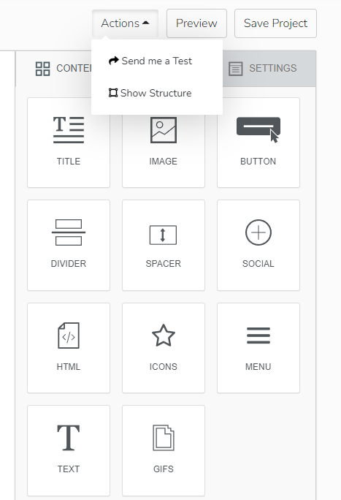
You can preview and/or send a sample directly from the email editor
You can find more information on the editor in the support section of the TruCentive website.

Landing Page
Our landing page builder is similar to our email builder, so the design options are the same. Note that limitations on width do not apply to the landing page so you may choose to go full width. You will still want to limit image size to provide fast load times on mobile devices.
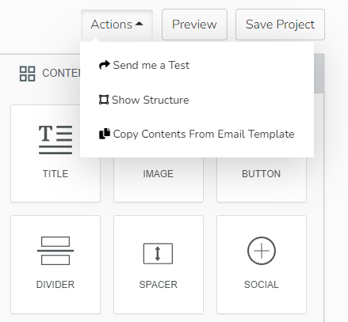

Deliveries
The Deliveries tab will show you any incentives that you have sent from your project along with all the details such as Created By, Envelope ID, Address, First Name, Last Name, Status, Created, Sent, and Viewed. You can also click on the last column “Actions” to perform certain actions to an envelope, such as Edit (change the name, number, or email of the recipient), Show (view the envelope), Resend (resend the envelope), Print (print the envelope), Revoke (invalidate the incentive)

Envelope Groups
Envelope Groups will show you any groups of envelopes that have gone out along with all the details of that send. You can click on the action drop-down to access the details of any envelope group.

Reminders
In the Reminders Tab, you can set up reminders to follow your original send. These automated emails will go out to recipients if they have not opened their email or claimed their incentive. You can also add a follow-up message that will go out after an incentive has been claimed. This is a great place to include surveys or other promotional materials.
- It’s a best practice to send reminders 1-3 days after your first delivery, then at a midpoint between the send date and the expiration data, and then 3-5 days before the expiration date.
- You can create unique reminders for every step of the way or select “use email message” to use your original email and only modify the subject line for the reminder.
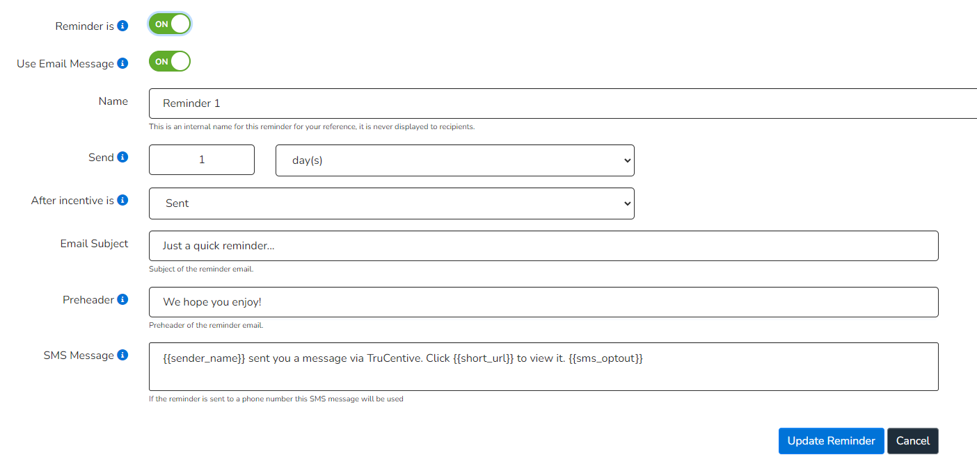

Integrations
The last tab is the Integrations tab; this is where you can connect integrations such as Survey Monkey, Zapier, or TruCentive API.

Congratulations! You have set up your first project and you are ready to start sending!
Send some test via add recipients in test mode to get some practice. Then under settings, set your project to “live” to send incentives with a monetary value.

